Text Splitters in LangChain
https://www.youtube.com/watch?v=SEWS9P4ODmc&list=PLKnIA16_RmvaTbihpo4MtzVm4XOQa0ER0&index=13
https://github.com/campusx-official/langchain-text-splitters
00:00 – Intro
00:37 - Text Splitting
09:55 - Length based Text Splitting
23:31 - Text-Structure based Text Splitting
39:05 - Document-Structure based Text Splitting
48:26 - Semantic Meaning Based
Text Splitters in LangChain – Complete Documentation

1. Introduction to RAG Components
The instructor welcomes viewers and explains that the channel has now moved into building RAG (Retrieval-Augmented Generation) based applications.
Previously, the first major component of RAG was discussed:
• Document Loaders
In this video, the second most important component is introduced:
• Text Splitters
The goal is to understand text splitting in detail and then later combine all RAG components to build a complete application.

2. What is Text Splitting?
Text splitting is the process of dividing a large piece of text into smaller, manageable chunks.
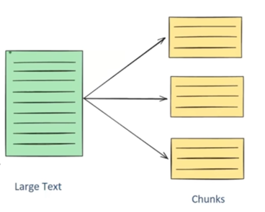
For example:
- A large PDF with thousands of pages
- A long article
- A book or HTML page
Instead of processing the entire content at once, the text is broken into smaller parts such as:
- Page-wise chunks
- Paragraph-wise chunks
- Character or token-based chunks
The tool or code that performs this operation is called a Text Splitter.
Definition:
Text splitting is the process of breaking large chunks of text (such as articles, PDFs, HTML pages, or books) into smaller manageable pieces that an LLM can handle effectively.

3. Why Text Splitting is Important in LLM Applications
Text splitting is critical when building LLM-powered applications for three major reasons:

3.1 Overcoming Context Length Limitations
Every LLM has a maximum input size (called context length).
For example:
- An LLM may accept only 50,000 tokens at a time
If a PDF contains:
- Thousands of pages
- More than 100,000 words
Then it cannot be directly sent to the model.
By splitting the document into smaller chunks:
- Each chunk fits within the model’s limit
- Large documents can be processed safely
This allows handling documents that would otherwise exceed model limitations.

3.2 Better Performance in Downstream Tasks
Text splitting improves quality in several common LLM tasks:
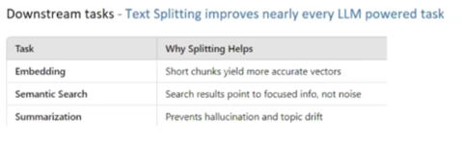
a) Embeddings
Embeddings convert text into numerical vectors that capture semantic meaning.
Problem with large text:
- A single large text block loses semantic clarity
- The embedding fails to represent detailed meaning
Solution:
- Split text into smaller chunks
- Generate embeddings for each chunk separately
Example:
If a document contains:
- Paragraph about CSK team
- Paragraph about MI team
- Paragraph about RCB team
Embedding the entire text together gives poor results.
But embedding each paragraph separately captures meaning much better.

b) Semantic Search
Semantic search compares embeddings to find relevant content.
With chunked documents:
- Search becomes more precise
- Results match user queries better
Example:
If separate chunks exist for different IPL teams and user asks:
"Which team does Virat Kohli play for?"
The system compares embeddings and retrieves the most relevant chunk.
Without splitting, search quality is much lower.

c) Summarization
Large documents cause problems like:
- Irrelevant output
- Hallucinations
- Topic drifting
By summarizing smaller chunks:
- Accuracy improves
- Output remains focused

3.3 Optimizing Computational Resources
Processing smaller chunks:
- Requires less memory
- Allows parallel processing
- Improves speed
This makes the application more efficient and scalable.

4. Types of Text Splitting Techniques Covered
The video will explain four major text splitting approaches:
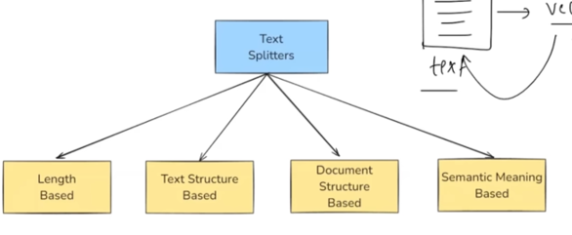
- Length-Based Text Splitting
- Text-Structure-Based Text Splitting
- Document-Structure-Based Text Splitting
- Semantic Meaning-Based Text Splitting
The first method is explained in this section.

5. Length-Based Text Splitting
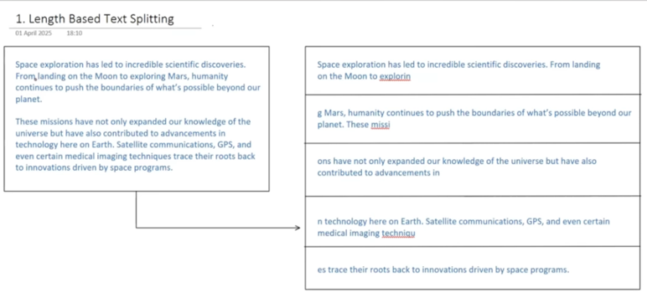
Length-based splitting is the simplest and fastest method.
Core Idea:
You predefine a fixed chunk size and split the text accordingly.
Chunk size can be defined using:
- Number of characters
- Number of tokens

5.1 How It Works
Example:
- Chunk size = 100 characters
Steps:
- Start reading text from beginning
- Count 100 characters
- Create first chunk
- Continue from where you stopped
- Create second chunk
- Repeat until text ends
Final result:
Text is divided into multiple equal-sized chunks.

5.2 Visualization Concept
If chunk size increases:
- Fewer chunks are created
If chunk size decreases:
- More chunks are created
This method strictly follows length and ignores meaning.

5.3 Advantages
- Very simple to understand
- Easy to implement
- Extremely fast

5.4 Disadvantages
- Ignores grammar
- Ignores sentence structure
- Ignores semantic meaning
Common problems:
- Words get cut in half
- Sentences break in the middle
- Paragraphs split abruptly
This leads to:
- Loss of context
- Poor embedding quality
- Less accurate search results
Because meaning is split across chunks.

6. Using CharacterTextSplitter in LangChain
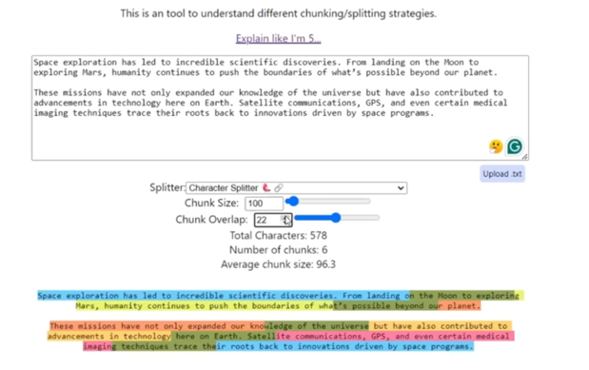
LangChain provides a built-in class:
CharacterTextSplitter
Basic Steps:
- Import the class
- Create a splitter object
- Define chunk size
- Optionally define chunk overlap
- Call split_text()
Example Workflow (Conceptual):
- Create splitter with chunk_size = 100
- Pass large text
- Receive list of chunks
Each chunk is returned as an element in a list.

7. Combining Document Loaders with Text Splitters
Workflow:
- Load PDF using PyPDFLoader
- Each page becomes a Document object
- Pass documents to text splitter
- Use split_documents() function
- Get chunked Document objects
Each chunk:
- Is still a Document object
- Contains page_content attribute
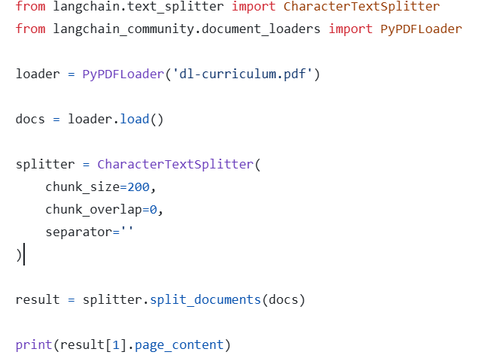

8. Chunk Overlap Concept
Chunk overlap controls how much content is shared between consecutive chunks.
Example:
If:
- Chunk size = 100 characters
- Chunk overlap = 5 characters
Then:
- Last 5 characters of chunk 1 appear in chunk 2
- Last 5 characters of chunk 2 appear in chunk 3
This creates overlapping regions.

8.1 Why Chunk Overlap is Useful
Without overlap:
- Text is cut abruptly
- Context is lost
With overlap:
- Important context is preserved
- Meaning flows across chunks
This improves:
- Embeddings
- Semantic search
- Retrieval quality

8.2 Trade-Off
Higher overlap:
- Better context
- More chunks
- Higher computation
Lower overlap:
- Faster
- Risk of context loss

8.3 Recommended Range for RAG
Common guideline:
If chunk size = 100
Then chunk overlap should be:
10 to 20 characters
As chunk size increases, overlap should increase proportionally.

9. Text-Structure Based Text Splitting
The next text splitting technique is called Text-Structure Based Text Splitting.
This technique is based on the idea that every text naturally follows a structure.
Usually, text is organized in the following hierarchy:
• Paragraphs
• Sentences inside paragraphs
• Words inside sentences
• Characters inside words
This hierarchical structure is used to intelligently split the text instead of cutting it randomly.
The most commonly used implementation of this approach in LangChain is called:
RecursiveCharacterTextSplitter
It is one of the most widely used text splitting techniques in real-world RAG applications.

10. Core Concept of Recursive Character Text Splitting
Instead of splitting directly by character count, this algorithm tries to split the text in a meaningful way using predefined separators.
Typical separators used (in order of priority):
- Paragraph separator → \n\n
- Line or sentence separator → \n
- Word separator → " " (space)
- Character level split (last fallback)

10.1 How the Algorithm Works (Step-by-Step Logic)
The algorithm follows this recursive process:
- First, try splitting by paragraphs
- If resulting chunks are still larger than allowed chunk size → split by sentences
- If still too large → split by words
- If still too large → split by characters
The goal is:
👉 Avoid breaking text abruptly in the middle
👉 Preserve meaning as much as possible
It only falls back to character-level splitting when no other option is possible.

11. Detailed Example of Recursive Splitting (Chunk Size = 10)
Sample Text Used:
My name is Nitish
I am 35 years old
I live in Gurgaon
How are you
Each line has a character count:
• First line → 17 characters
• Second line → 17 characters
• Third line → 17 characters
• Fourth line → 11 characters
Allowed chunk size = 10 characters

11.1 Step 1: Paragraph Level Split
The algorithm first splits using \n\n (paragraph separator)
This creates two paragraphs:
Paragraph 1:
"My name is Nitish
I am 35 years old"
Paragraph 2:
"I live in Gurgaon
How are you"
Sizes:
• Paragraph 1 → 34 characters
• Paragraph 2 → 28 characters
Both are larger than allowed chunk size (10)
So further splitting is needed.

11.2 Step 2: Sentence Level Split
Now it splits by \n (sentence level)
From Paragraph 1:
• "My name is Nitish" (17)
• "I am 35 years old" (17)
Still greater than 10 → continue splitting.

11.3 Step 3: Word Level Split
"My name is Nitish" becomes:
• My (2)
• name (4)
• is (2)
• Nitish (6)
All are below chunk size.

11.4 Optimization Through Merging
The algorithm now tries to merge smaller chunks to get closer to allowed size without exceeding it.
Merging process:
"My" + "name" → "My name" (7 characters)
"My name" + "is" → "My name is" (10 characters)
Cannot add "Nitish" because:
10 + 6 = 16 (exceeds limit)
So final chunks:
• "My name is"
• "Nitish"

11.5 Same Process for Remaining Sentences
"I am 35 years old" becomes:
• I
• am
• 35
• years
• old
After merging:
• "I am 35"
• "years old"

"I live in Gurgaon" becomes:
• "I live in"
• "Gurgaon"

"How are you" becomes:
• "How are"
• "you"

11.6 Final Output for Chunk Size = 10
The final chunks are:
• My name is
• Nitish
• I am 35
• years old
• I live in
• Gurgaon
• How are
• you

12. Example with Larger Chunk Size (25)
Now allowed chunk size = 25 characters

Step 1: Paragraph split
Paragraph sizes:
• 34 characters
• 28 characters
Both still larger than 25 → continue.

Step 2: Sentence split
Now each sentence:
• "My name is Nitish" → 17
• "I am 35 years old" → 17
• "I live in Gurgaon" → 17
• "How are you" → 11
All are now below 25.
So no further splitting is required.

Final Output for Chunk Size = 25:
• My name is Nitish
• I am 35 years old
• I live in Gurgaon
• How are you
Each chunk corresponds to a full sentence.

13. Example with Chunk Size = 50
Now allowed chunk size = 50 characters

Step 1: Paragraph split
Paragraph sizes:
• Paragraph 1 → 34 (allowed)
• Paragraph 2 → 28 (allowed)
Both fit within the limit.
So no further splitting happens.

Final Output for Chunk Size = 50:
• First paragraph as one chunk
• Second paragraph as one chunk
Now chunks are paragraph-based.

14. Key Observation from These Examples
As chunk size changes, the splitting level adapts automatically:
Chunk Size | Splitting Level
Very small | Character / word
Medium | Sentence
Large | Paragraph
Very large | Entire document

This makes Recursive Character Text Splitting much smarter than simple length-based splitting.

15. Why This Technique is Better than Simple Character Splitting
Advantages:
• Preserves sentence structure
• Avoids breaking words randomly
• Maintains context better
• Produces meaningful chunks
• Improves embedding quality
• Improves retrieval accuracy
This is why it is the most commonly used text splitter in LangChain projects.

16. Using RecursiveCharacterTextSplitter in LangChain (Conceptual Steps)
- Import the class from LangChain
- Create a splitter object
- Set:
  - chunk_size
  - chunk_overlap
- Call split_text() on your text
text_structure_based.py
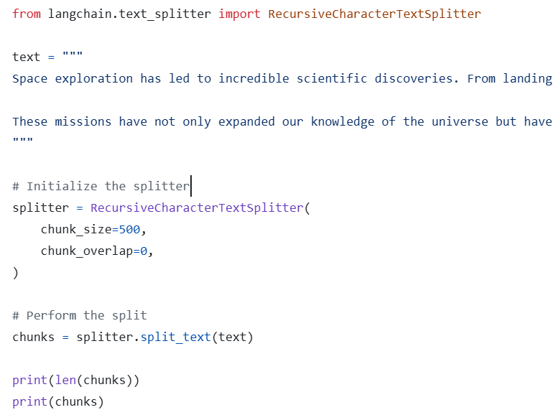

Typical Usage Flow:
- Provide large text
- Split into chunks
- Receive list of smaller text segments
As chunk size increases:
• Fewer chunks are created
• Structure is preserved better

17. Practical Observation from Code Demo
When:
chunk_size = 100
• Output may break mid-sentence
When:
chunk_size = 300
• Output aligns with paragraph structure
When:
chunk_size = 500
• Entire content may appear as one chunk

18. Conclusion on Text-Structure Based Splitting
Recursive Character Text Splitting:
• Uses text hierarchy intelligently
• Adapts to chunk size dynamically
• Avoids abrupt breaks
• Preserves meaning as much as possible
Because of these qualities:

19. Document-Structure Based Text Splitting
In the previous section, we discussed Text-Structure Based Text Splitting, where we used natural language structure such as:
• Paragraphs
• Sentences
• Words
• Characters
However, not all documents are plain natural language text.
Many real-world documents are written in special formats, such as:
• Source code (Python, JavaScript, Java, etc.)
• Markdown files
• HTML files
• PDFs with structured layouts
These documents do not follow normal paragraph and sentence organization.
For example:
- Code is organized using classes, functions, loops, and conditions
- Markdown is organized using headings, lists, sections, and formatting symbols
Because of this, normal text splitters are not suitable for such documents.

20. Core Idea of Document-Structure Based Splitting
This technique is an extension of Recursive Character Text Splitting.
The main difference is:
👉 Instead of using paragraph and sentence separators, it uses document-specific separators
Examples:
For Python Code:
• class keyword for class definitions
• def keyword for functions
• Indentation blocks
• Loops and condition blocks
For Markdown:
• Headings (#, ##, ###)
• Lists
• Section breaks
After using these custom separators, the splitter can still fall back to:
• Paragraph level
• Sentence level
• Word level
• Character level
Just like the recursive approach.

21. Why This Approach is Needed
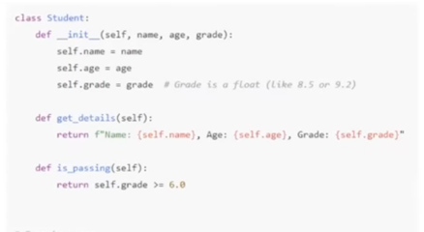
If we treat code or markdown as plain text:
• Paragraph splitting will not work correctly
• Sentence splitting makes no sense
• Context will break
But when we split based on:
• Code constructs
• Markdown sections
We preserve:
• Logical boundaries
• Meaningful chunks
• Better context for LLMs

22. Visual Demonstration with Markdown
A markdown file was used containing four main sections:
- First section
- Features section
- Tech stack section
- Getting started section
Initially, with very small chunk size:
• Many small illogical chunks were created (around 64)
As chunk size increased gradually:
• Structure became clearer
• Chunks aligned with markdown sections
At around chunk size ≈ 175:
The output correctly produced:
• One chunk per markdown section
This showed that:
👉 Recursive Character Text Splitter was still working
👉 But with markdown-specific separators

23. Visual Demonstration with Python Code
A Python file containing:
• A class definition
• Multiple methods inside the class
• Object creation
• If-else condition
When split using Python language mode:
Results:
• One chunk for the class and constructor
• Separate chunks for methods
• Separate chunk for object usage
• Separate chunk for conditional logic
With higher chunk size:
• Entire class became one chunk
• Usage code became another chunk
This again confirms:
Same algorithm, but customized separators.

24. Implementing Document-Structure Splitting in LangChain (Conceptual Flow)
Steps:
- Import RecursiveCharacterTextSplitter
- Specify the document language or format
- Define:
  - chunk_size
  - chunk_overlap
- Call split_text()
Example 1: python_code_splitting.py
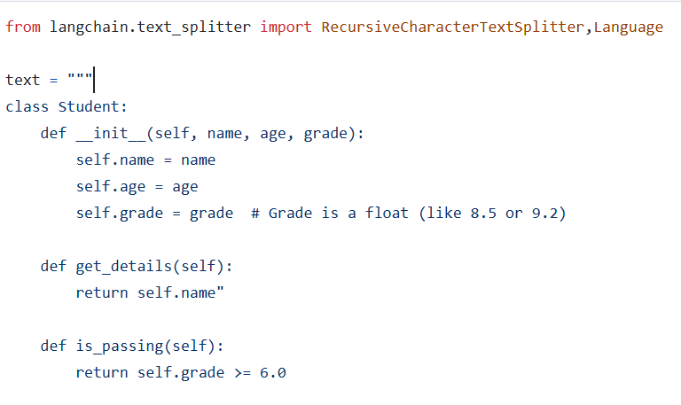

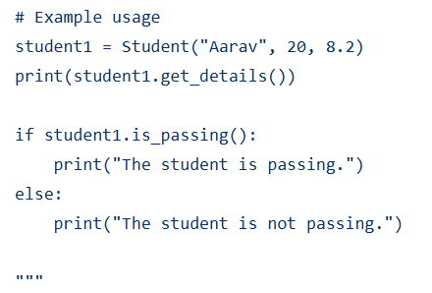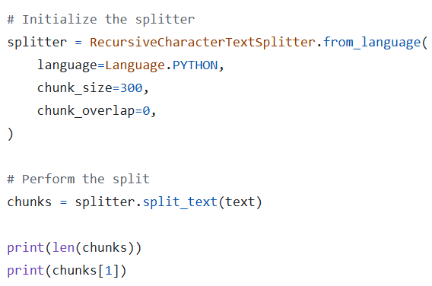

Example 2: markdown_splitting.py
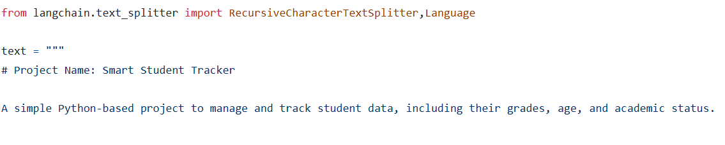
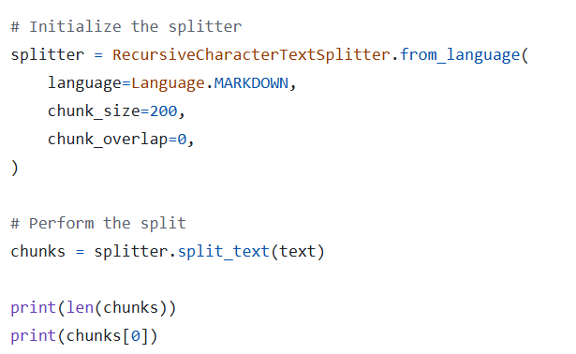

Key Difference in Code Usage:
Instead of creating splitter directly, LangChain provides:
A method that configures separators automatically based on language.
You specify:
• Language = Python
• Language = Markdown
• Language = HTML
LangChain then applies suitable separators internally.

25. Supported Document Types
LangChain supports structured splitting for:
• Python
• JavaScript
• Java
• PHP
• HTML
• Markdown
• Many other formats
This makes it very powerful for:
• Code-based RAG systems
• Documentation-based chatbots
• Developer assistants

26. Summary of Document-Structure Based Splitting
This approach:
• Uses Recursive Character Text Splitter internally
• Applies format-specific separators
• Preserves logical boundaries
• Works well for non-plain-text documents
It is especially useful for:
• Source code processing
• Technical documentation
• Markup files

27. Semantic Meaning Based Text Splitting
So far, we have seen two major approaches:
- Length-Based Splitting
- Structure-Based Splitting
However, there are situations where both approaches fail.

27.1 Problem with Length and Structure Based Splitting
Consider a paragraph that contains:
• Multiple unrelated topics in the same paragraph
Example:
- First half talks about agriculture and farmers
- Second half talks about IPL cricket
Structurally:
👉 It is one paragraph
But semantically:
👉 It contains two completely different topics
Using structure-based splitting would create:
• One chunk for entire paragraph
Which leads to:
• Poor embeddings
• Mixed context
• Lower retrieval quality

28. Goal of Semantic Meaning Based Splitting
Instead of using:
• Length
• Structure
This approach uses:
👉 Meaning of the text
It tries to detect:
• Topic changes
• Context shifts
And splits text exactly where meaning changes.

29. How Semantic Splitting Works (Conceptual Process)
Step 1: Sentence Breakdown
The text is first divided into individual sentences.
Example:
S1, S2, S3, S4, ...

Step 2: Generate Embeddings
Each sentence is sent to an embedding model (such as OpenAI embeddings).
This produces:
• Vector representation for each sentence

Step 3: Compare Consecutive Sentences
For each adjacent pair:
• Compare S1 vs S2
• Compare S2 vs S3
• Compare S3 vs S4
Using:
• Cosine similarity (or distance)

Step 4: Detect Meaning Shift
If similarity suddenly becomes very low:
👉 It indicates a topic change
That point is selected as a split location.

Step 5: Sliding Window Strategy
The algorithm keeps moving forward comparing sentence by sentence.
Wherever a major drop in similarity occurs:
• A new chunk is created
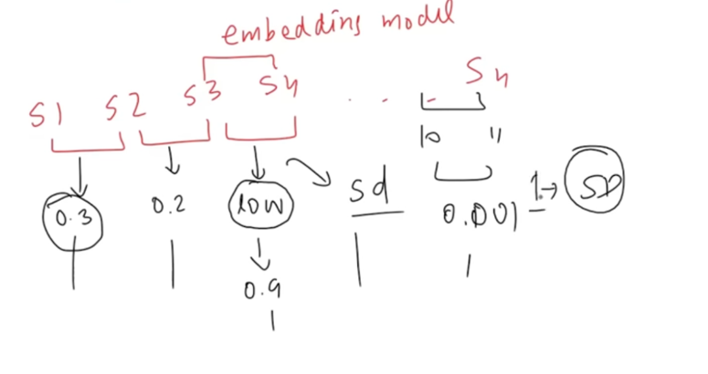

30. Threshold Mechanisms for Splitting
To decide when similarity is “low enough”, several threshold strategies are used:
• Standard deviation
• Percentile
• Interquartile range
• Gradient-based change

Example: Standard Deviation Method
- Compute similarity scores for all consecutive sentence pairs
- Calculate standard deviation of these scores
- If any similarity deviates strongly (beyond threshold):
→ Mark it as split point

31. LangChain Implementation Status
LangChain provides this through:
• Experimental semantic chunkers
Important points:
• Not part of core library yet
• Still experimental
• Results are inconsistent
semantic_meaning_based.py
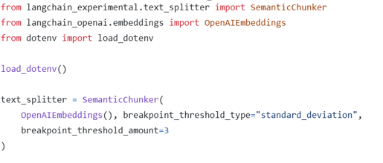
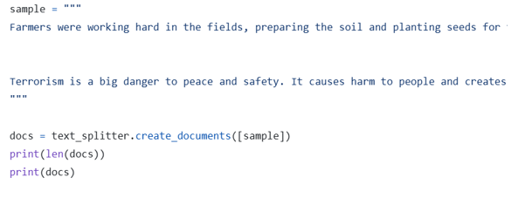

32. Practical Results Observed
Expected:
• Three chunks (agriculture, IPL, terrorism)
Actual output:
• Chunks were imperfect
• Some lines mixed into wrong topics
Adjusting threshold:
• Higher threshold → fewer splits
• Lower threshold → more splits
But overall:
👉 Results were not very reliable

33. Limitations of Semantic Splitting (Current Stage)
• Computationally expensive (embeddings required)
• Threshold tuning is tricky
• Inconsistent performance
• Still evolving

34. Current Best Practice Recommendation
Among all approaches discussed:
Best and Most Reliable:
👉 Recursive Character Text Splitter
Because:
• Simple
• Fast
• Consistent
• Preserves structure well
This is the splitter you will use most often in LangChain projects.

35. Final Summary of All Text Splitting Approaches
Approach | Basis | Reliability | Usage
Length-Based | Character/Token count | Medium | Simple tasks
Text-Structure Based | Paragraph/Sentence/Word | High | Most common
Document-Structure Based | Code/Markdown constructs | High | Special documents
Semantic Meaning Based | Context similarity | Low (currently) | Experimental

So far in this video we have covered:
• Length Based Splitting
• Text Structure Based Splitting
• Document Structure Based Splitting
• Semantic Meaning Based Splitting

